Statistics – What I need to do

- Finish practice exam
- Go through the multiple choice again
- Write out all the distributions and the rules associated with the usage of them
- Watch these videos: https://www.youtube.com/watch?v=jmqZG6roVqU&app=desktop
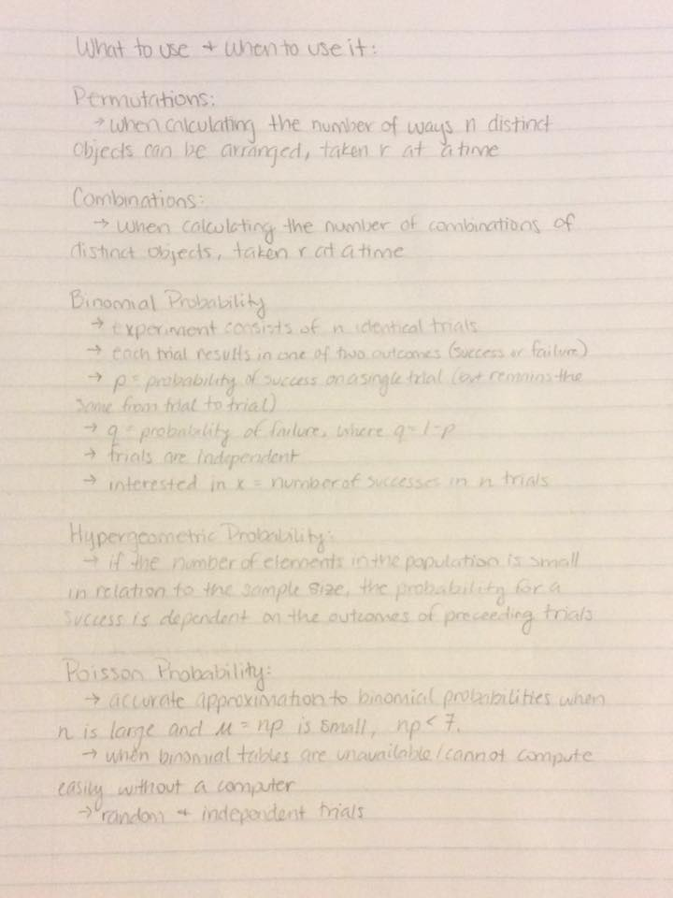
- Alif's notes
- Find all the things I will need to memorize.
  - Distribution usage rules (above)
  - Chebyshev's inequality – equation and concepts
  - Normal approximation to binomial w/ continuity correction
  - Covariance (it's kind of on the sheet on top of the formula for r, except it has a n-1 on the bottom)
- Look for notes on usage of Poisson

